Life Expectancy By Country
Problem Statement: Technological and medical progress has raised human life expectancy, yet large cross-country differences remain. This analysis investigates whether a country’s economic success (measured by GDP) is associated with higher average life expectancy, using data on 158 countries.
Solution Strategy: 1) Extract the life-expectancy vector and compute its quartiles + histogram. 2) Compute the median GDP and split countries into low-GDP (≤ median) and high-GDP (> median) groups. 3) Compare the life-expectancy quartiles and histograms of the two groups. 4) Quantify the gap with IQR, means/medians and Spearman correlation; run a Monte-Carlo simulation under noise and alternative split thresholds.

Solution
Overall life expectancy quartiles: Q1 = 61.5, Median = 71.1, Q3 = 74.8 years (range 48–83.5).
Median GDP threshold: 9,109.
Low-GDP group LE quartiles: 48.0 / 54.1 / 62.7 / 69.0 / 72.9 (median ≈ 62.7 yrs).
High-GDP group LE quartiles: 49.4 / 72.8 / 74.8 / 78.4 / 83.5 (median ≈ 74.8 yrs).
Key contrast: High-GDP countries live ~12 years longer at the median; their distribution is much tighter (IQR 5.6 vs 14.9). Spearman correlation GDP–LE ≈ 0.92.
A country with LE = 70 years falls in the upper half of the low-GDP distribution but in the lower half of the high-GDP distribution — illustrating how the same absolute value has very different relative meaning depending on economic context.
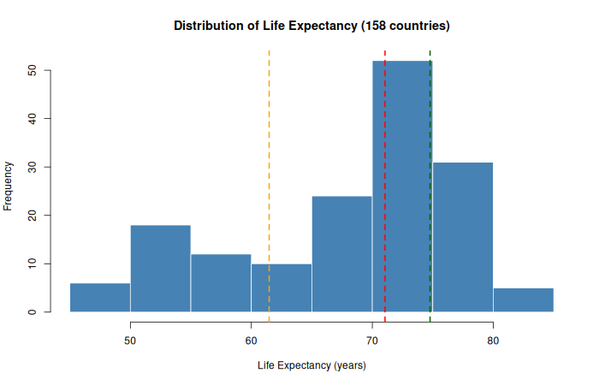
Overall life-expectancy distribution with quartile markers

Key Takeaways
• Higher national GDP is strongly associated with longer life expectancy; the median gap is approximately 12 years.
• The high-GDP group is far more homogeneous (smaller IQR), while the low-GDP group contains the countries with the lowest LE values.
• Monte-Carlo simulation with modest noise (σ = 1.5) still yields a stable positive gap (mean ≈ 12 years, 95 % MC interval roughly 10.5–13.4).
• Audience adaptation: analysts receive exact quartiles and correlation; executives receive the headline gap and a single comparative histogram pair.
Files: Practice_Skeleton.ipynb | Solution.ipynb | Cheatsheet | data/country_data.csv | flowchart & plots

